ChE 2O04 Tutorial #4 – Introduction to PIPE-FLO
Ensure that PIPE-FLO Advantage is installed on your computer, fully activated and all the units are SI.

NOTE: This tutorial is NOT a substitute for studying the full PIPE-FLO courseware that is posted on Avenue-to-Learn; it is simply meant to give you a quick introduction to the software and its intricacies.

- We will be introducing how to make a simple system on PIPE-FLO including making fluid zones, specifications, and using devices such as tanks, valves, bends, etc.
- The FLO-SHEET for the system as shown below is posted on Avenue-to-Learn.

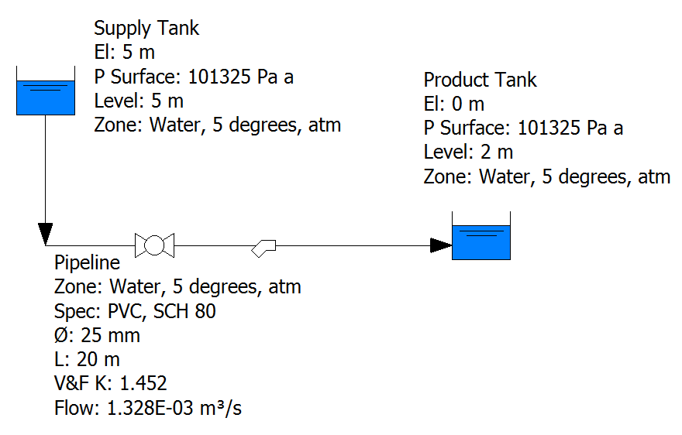
V&F K: 90° Mitre Bend and fully opened Ball Valve

Questions:
- Using your intuition, which way would the water flow, what forces are acting on the fluid?

- What is the flow rate of water in the pipeline connecting the two tanks? What is the average velocity of the water in the pipeline?

- What happens if you change the liquid level in the Product Tank to 20 m? Why?

Tutorial Activities

- Setup the system at the default conditions shown in the image above and then explore/report the effect of the various process changes described below on the flow rate in the pipe connecting to the two tanks.

  - How does the flowrate change with pipe length (20, 40, 60 m) and pipe diameter (25, 32, 40 mm)? Report the volumetric flowrate and Reynolds number for each and comment and whether the flow is laminar or turbulent. If none of the cases show laminar flow, propose a set of values that would, based on the observed trends.

The threshold for laminar flow is when the Re ≤ 2300. The transition period is when 2300 < Re < 4000, Turbulent flow is when Re > 4000 (Fox and Macdonald, and the lecture notes).

The following values are reported for water at 5◦C, with PVC schedule 80 piping, and the supply tank liquid level at 5 m, with both tanks exposed to atmosphere.

Volumetric Flowrate at a supply tank liquid level of 5 m ($m^{3}/hr⁡)$:

 | Pipe Diameter (mm)
Length of pipe  (m) | 25 | 32 | 40
20 | 1.328e-03 | 2.842e-03 | 4.316e-03
40 | 9.206e-04 | 1.990e-03 | 3.042e-03
60 | 7.326e-04 | 1.601e-03 | 2.454e-03

Reynolds Number at a supply tank liquid level of 5 m

 | Pipe Diameter (mm)
Length of pipe  (m) | 25 | 32 | 40
20 | 45,823 | 73,413 | 95,006
40 | 31,763 | 51,408 | 66,957
60 | 25,449 | 41,362 | 54,014

- As the pipe length increases from 20 to 60 m, the volumetric flowrate decreases along with the Reynolds number. This is due to energy being lost to friction and the amount of energy lost increasing as the pipe length increases.
- As the pipe diameter increases from 25 to 32 mm, the friction factor changes from 0.02152 to 0.01942. The friction factor is decreasing as, since the pipe material is the same, the ratio of the pipe’s surface roughness to its diameter is decreasing. A greater proportion of the fluid is no longer in contact with the walls, reducing the relative impact of fraction. As less energy is lost to friction in the large pipe, the flowrate increases along with the Reynolds number.
- None of the cases are at the point where the flow is laminar. To achieve laminar flow (Re < 2300), we modulated the variable values:
  - By keeping length of pipe the same and decreasing pipe diameter to the smallest value (6 mm), the flow dropped to2.011e-05 m3/sec and the Re to 3088.
  - To further drop the Reynolds number, the length was increased to 100 m, resulting in a Re of 2161, and a flowrate of 1.407e-05 m3/sec.

  - How does the above trends change with the supply tank liquid level? Build the same charts for a supply tank liquid level of 10 and 15 m. Report which combination of values provides laminar vs. turbulent flow and present some possible regions for the transition in flow.

Volumetric Flowrate at a supply tank liquid level of 10 m (($m^{3}/hr⁡)$:

 | Pipe Diameter (mm)
Length of pipe  (m) | 25 | 32 | 40
20 | 1.739e-03 | 3.711e-03 | 5.630e-03
40 | 1.208e-03 | 2.607e-03 | 3.980e-03
60 | 9.696e-04 | 2.100e-03 | 3.215e-03

Reynolds Number at a supply tank liquid level of 10 m

 | Pipe Diameter (mm)
Length of pipe  (m) | 25 | 32 | 40
20 | 59,981 | 95,881 | 123,931
40 | 41,694 | 67,340 | 87,610
60 | 33,454 | 54,259 | 70,777

Volumetric Flowrate at a supply tank liquid level of 15 m $(m^{3}/hr⁡):⁡$

 | Pipe Diameter (mm)
Length of pipe  (m) | 25 | 32 | 40
20 | 2.081e-03 | 4.436e-03 | 6.724e-03
40 | 1.449e-03 | 3.122e-03 | 4.763e-03
60 | 1.164e-03 | 2.518e-03 | 3.852e-03

Reynolds Number at a supply tank liquid level of 15 m

 | Pipe Diameter (mm)
Length of pipe  (m) | 25 | 32 | 40
20 | 71,796 | 114,601 | 148,009
40 | 50,001 | 80,646 | 104,845
60 | 40,156 | 65,042 | 84,783

- We can see that as the supply tank liquid level increases; the flowrate increases at the same pipe length and diameter values. This is due to the greater pressure at the tank outlet caused by the larger volume of water, causing the fluid flowrate to increase from one tank to the other.

  - What is the combination of values in the above three variables that provides the highest flow rate? Present some reasons for why that is.

- Given that flowrate increases with:
  - Shorter pipe length (less energy lost to friction)
  - Larger pipe diameter (less energy lost to friction)
  - High supply tank liquid level (more energy available to drive flow)
- We can see that the largest flowrate values (6.724e-03 m3/sec) is predicted when the supply tank liquid level is 15m, the length of the pipe is 20 m, and the pipe diameter is 40 mm.

What we should address in the introduction:
- What the first screen looks like after pressing :
This is where you can change units, create specifications for pipes, and create fluid zones.

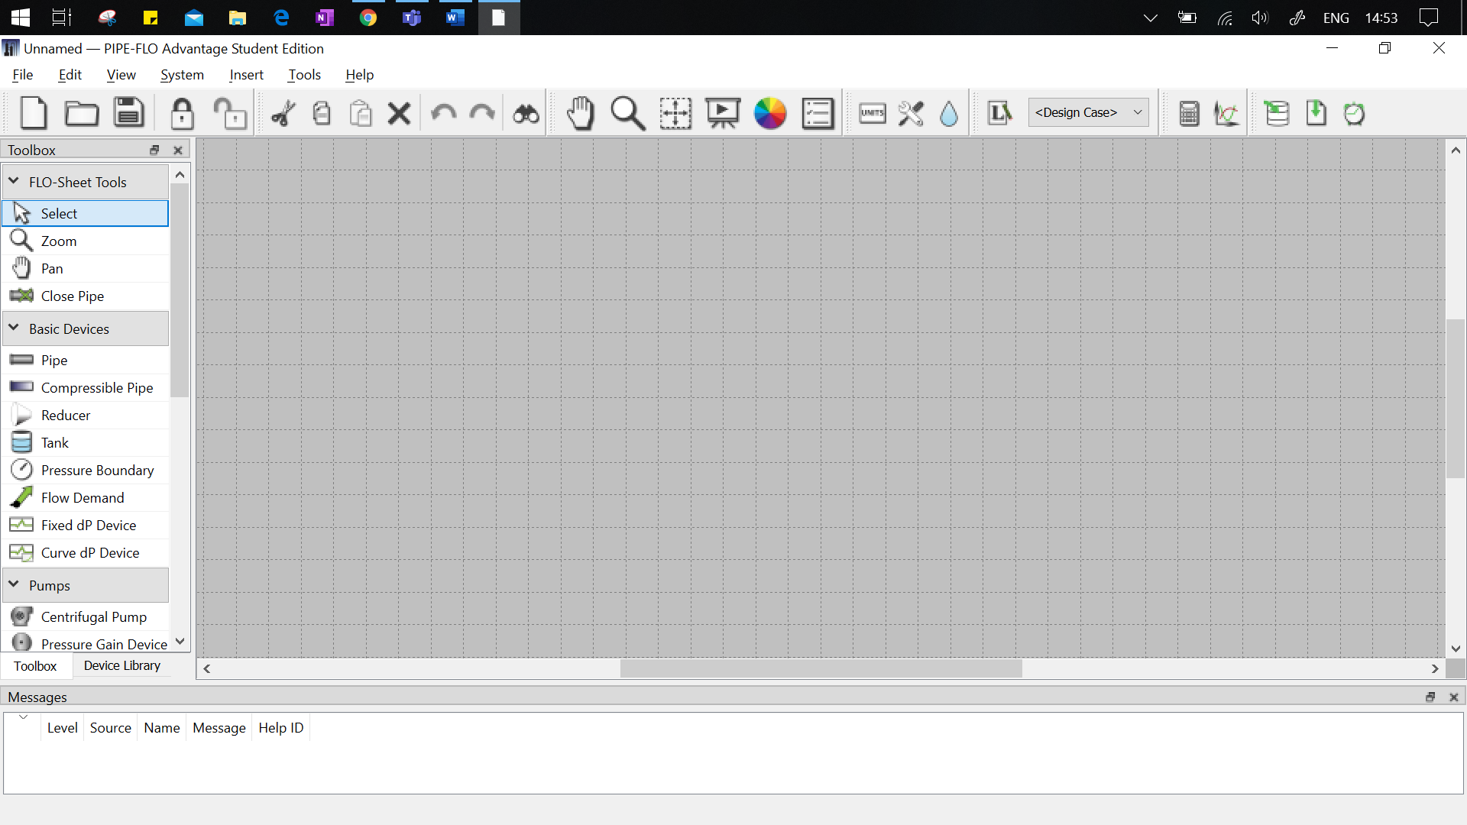
This is where you can save, open, start a new file (the same keyboard shortcuts apply). This is also where more display boxes can be opened such as Property Grid or List View.
This button will be used to toggle the system’s calculation mode. It will provide values such as the flow rate or pressure in the system.
Of course, this is where the system will be built! It is impertinent to zoom in.

Important! This is where errors will be displayed.

This is where tools and devices are listed. We will be using pipes, tanks, and pumps later on.

- The first thing that needs to be done is changing the pressure from gauge to absolute and changing all the units to SI.
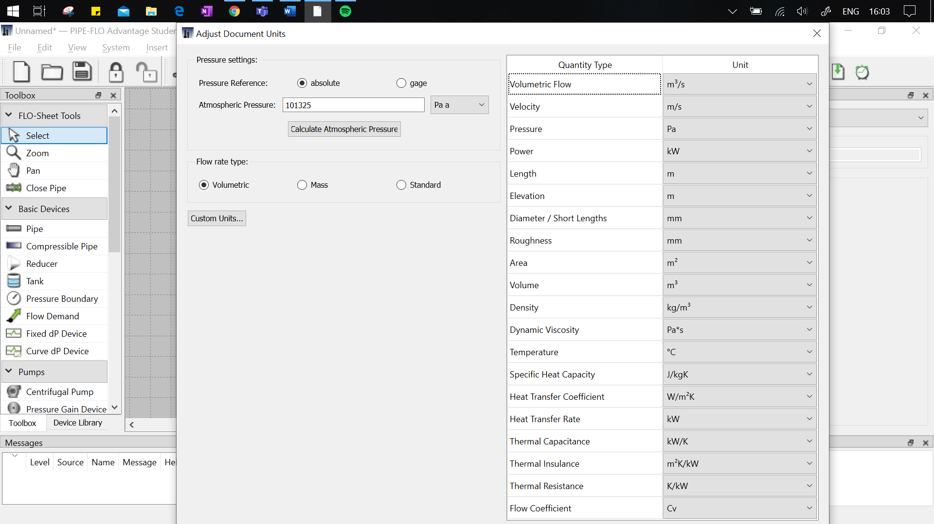

- Next, it is important to cover the types of errors that can come about when building a system. PIPE-FLO uses levels to share the urgency:
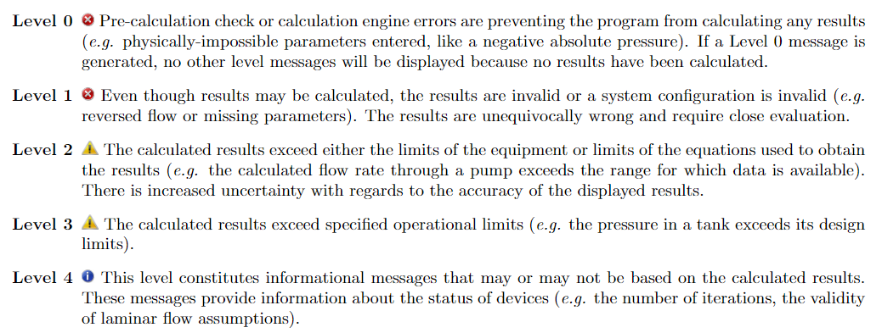
- Save the file as the default project named “PIPE-FLO_Tutorial”, this way all the settings will stay the same for any subsequent projects.
- To begin creating the system, first we will create the fluid zone. Click the droplet 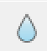 in the top bar to begin, click new:
  - Fluid Zone Name: Water, 4 degrees, atm
  - Fluid Type: NIST
  - Available Fluids: Water
  - Fluid Properties, Temperature: 4 degrees
  - Fluid Properties, Pressure: 101325 Pa
This is where information on the fluid can be set (temperature and pressure) so that the other properties can be calculated (density, viscosity, vapour pressure)

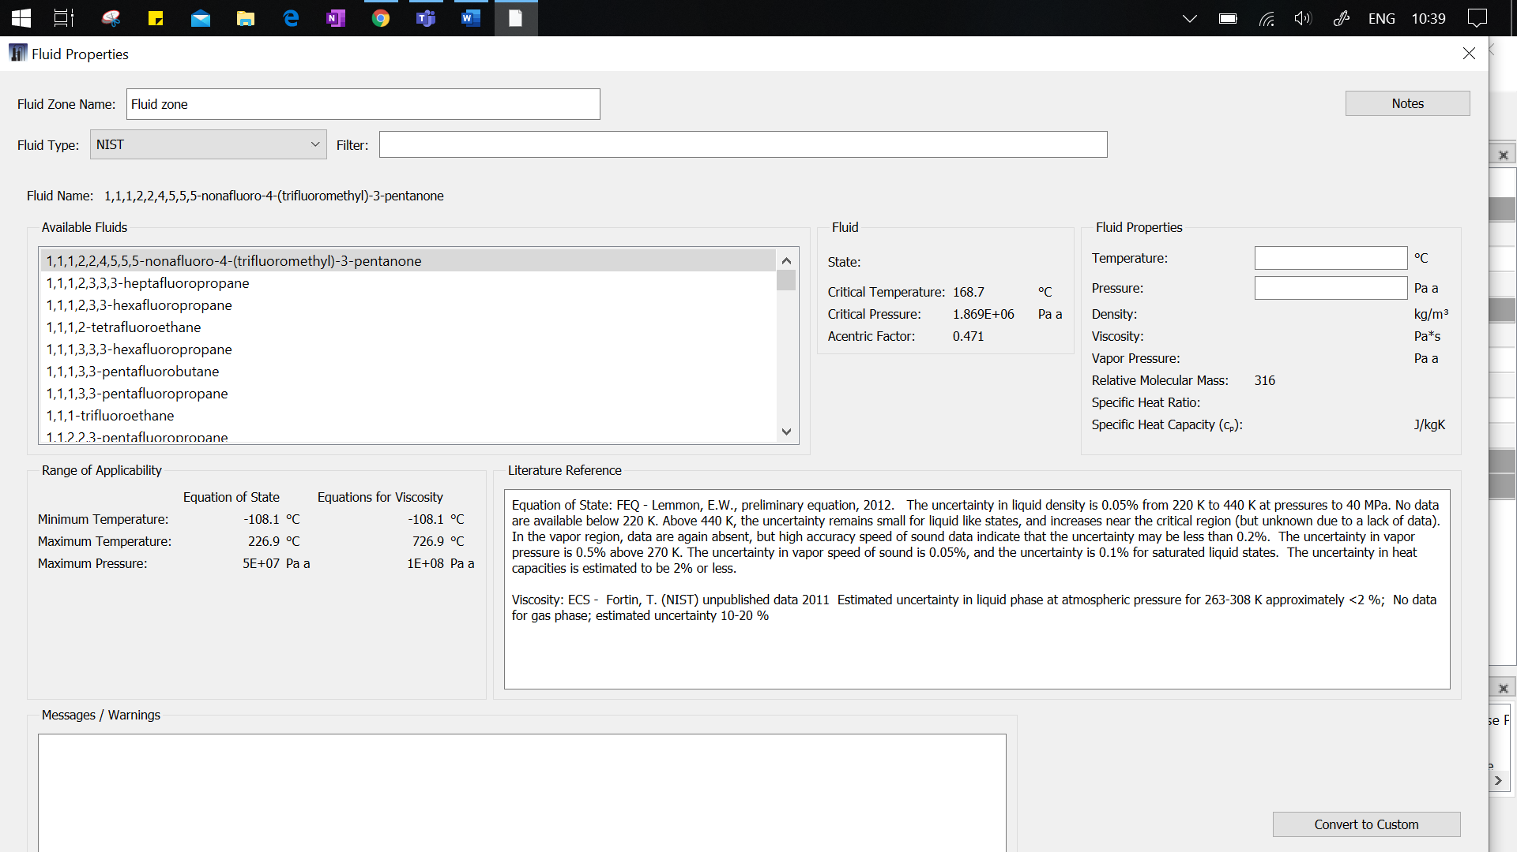
There are many fluid types available, including custom if there is no alternative.

- Once finished, it should look like this:
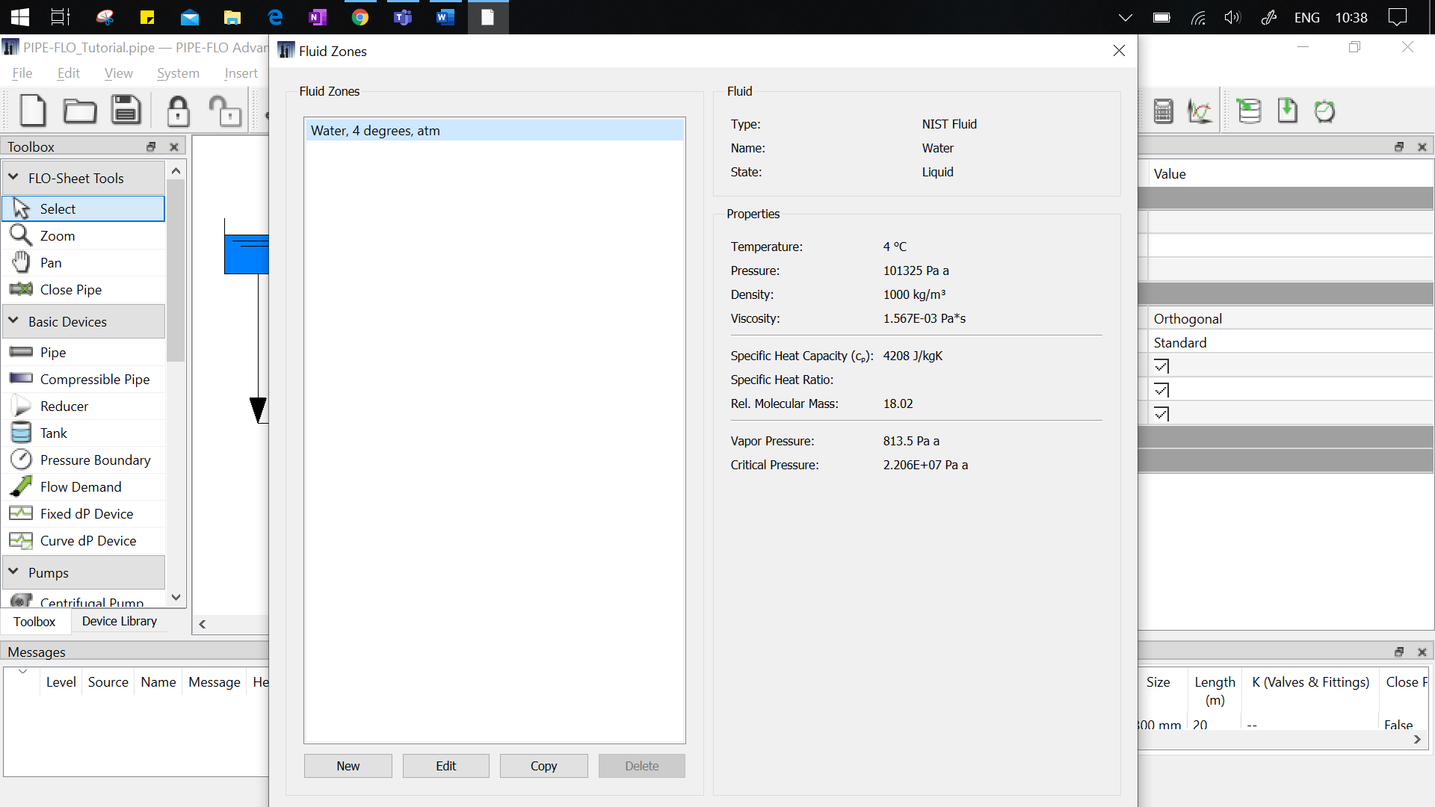
- The next step is to create the pipe specification. Press okay and click the wrench and screwdriver  in the top bar to begin, click new:
  - Name: PVC, SCH 80
  - Installed Pipe Tables: ∨ PVC Plastic Pipe, 80
- Once finished, it should look like this:
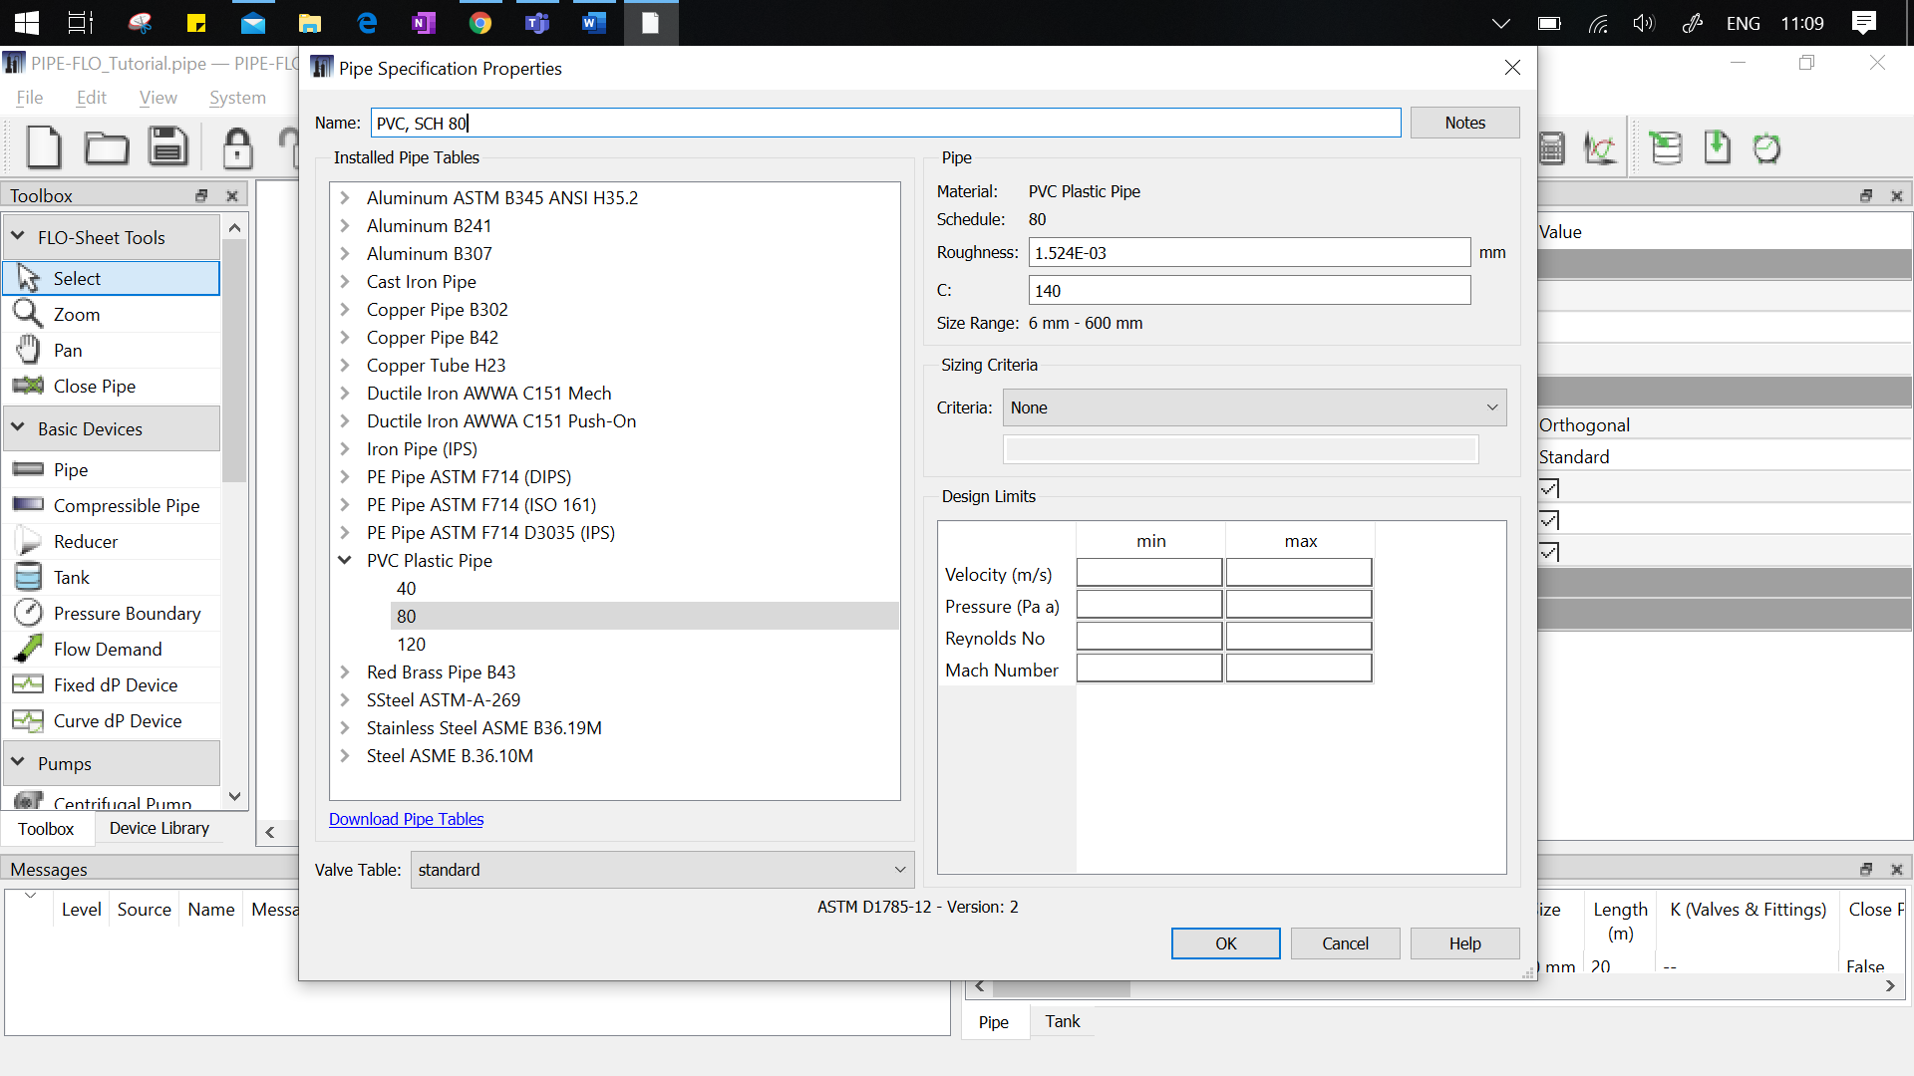
- Next, we will start placing basic devices.
- Underneath the toolbox panel on the left, select tank and place it on the grid. Place another tank onto the grid and then press Esc to alight the device from the cursor. *It does not actually matter where the tank is placed, only the properties will dictate how the fluid behaves. However, keeping the system to scale is a visual method of making sure everything is working correctly.*

- Click on Tank 1 to access and change its properties.
  - Name: Supply Tank
  - Elevation: 5 m
  - Surface Pressure: 101325 Pa a
  - Liquid Level: 5 m
  - Fluid Zone: Water, 4 degrees, atm
  - Everything else can be left unspecified .
- Click on Tank 2 to access and change its properties.
  - Name: Product Tank
  - Elevation: 0 m
  - Surface Pressure: 101325 Pa a
  - Liquid Level: 2 m
  - Fluid Zone: Water, 4 degrees, atm
  - Everything else can be left unspecified.
- Underneath the toolbox panel on the left, select pipe and hover over the Supply Tank. You will notice arrows, click on the tank to attach the pipe to it.
- Keep dragging the pipe until the other end is attached to the Product Tank. You can click the grid if you need to bend the pipe.
- Click on Pipe 1 to access and change its properties.
  - Name: Pipeline
  - Fluid Zone: Water, 4 degrees, atm
  - Specification: PVC, SCH 80
  - Size: 100 mm
  - Length: 20 m
  - K (Valves & Fittings): > Bend, Mitre Bend @ 90°, add, then > Valves and add Ball, then the value 1.038 should be displayed.
  - Everything else can be left unspecified.
- Now that the system has been built, it can be verified with the image above and parameters can be calculated using F5 or pressing the calculator button . Please answer the attached questions.

